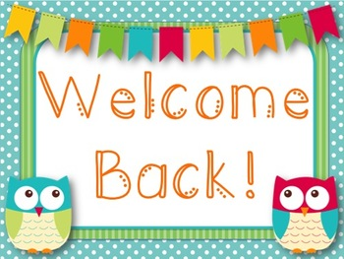

Year 2

Curriculum Map Autumn 1

**English**

We will continue to use Read Write Inc. to teach phonics. Your child will be learning and recapping all the phonemes and graphemes to ensure that they are confident to segment and blend sounds in order to read both real and alien words. Your child will also engage in daily reading practise through the scheme.

Our ‘book as hook’ for this half-term is ‘The Rainbow Fish’ by Marcus Pfister. We will be writing narratives, diary entries and non-chronological reports based on the text. We will also read the poem ‘What we found at the Seaside’ by Kate Williams and create our own poems to describe a setting. We will be using our phonics knowledge to spell words and ensuring that we use the appropriate punctuation and grammar in our writing.

P.E. will take place on Mondays and Tuesdays for this half-term. Please send children into school in their P.E. kits on these days. Thank you.

**Maths**

We will continue to follow the White Rose Maths scheme and learn through a concrete, pictorial and abstract approach. This half-term we will be focussing on place value and addition and subtraction. We will learn how to represent numbers up to 100, begin to add 2-digit numbers and use the inverse relationship to solve number problems.

**Religious Education**

Our RE focus question is ‘How do we show we care for others?’

We will be reflecting on why each individual is special and unique and researching how people show they care for others though charity work.

**Science**

Our topic this half-term is ‘Animals including humans’.

We will be learning about how animals need the basic needs of water, food and air for survival. We will be learning about the importance for humans of hygiene, exercise and eating a balanced diet. We will also be learning about how different animals grow.

**Creative Curriculum**

This half-term term we will be conducting a local history study of Leigh!

We will be researching the history of Leigh, finding out about the coal mines and mills that populated the town and using a range of historical sources to conduct our enquiries. We will also be looking at the geography of Leigh, finding out about the key human and physical features of the town.